ACUTE CHANGES TO EXERCISE. CHAPTER 4 (A+ NOTES PAGES 87-90)
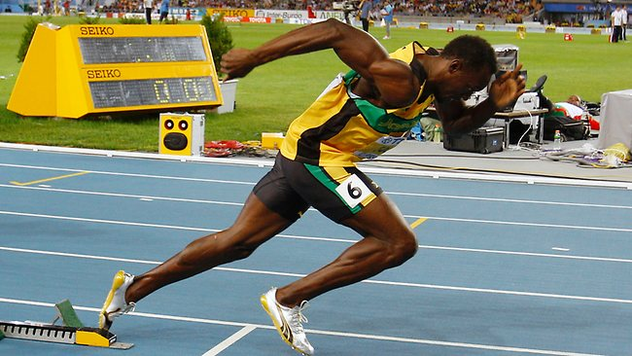
Usain Bolt start for the 200m sprint
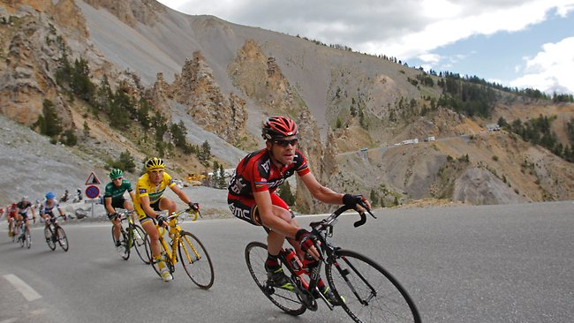
Cadel Evans climbing an Alpe in Le Tour de France
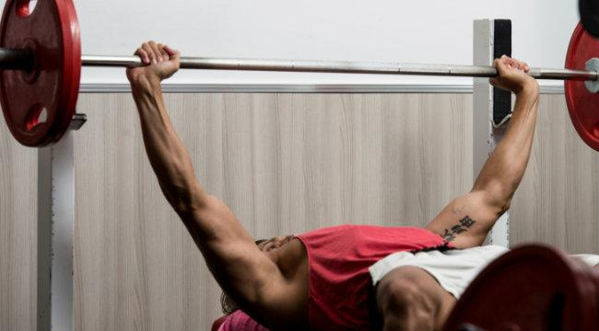
The bench press as part of a weights circuit

For the above three photos, identify one Acute change to the specific exercise for each of the cardiovascular, respiratory and muscular systems. Also discuss physiologically, how it improves/aides improved performance of the athlete.

Usain Bolt
Cardiovascular

Respiratory

Muscular

Cadel Evans
Cardiovascular

Respiratory

Muscular

Weight Trainer
Cardiovascular

Respiratory

Muscular

