Acute Responses to Exercise
Study the graph below which shows oxygen uptake (VO₂) before, during and after exercise
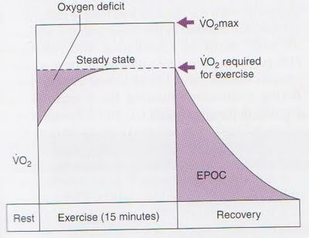

- Define the following:
  - VO₂ ________________________________________________________________________________________________________________________________________________

  - Oxygen deficit
________________________________________________________________________________________________________________________________________________
  - VO₂max
________________________________________________________________________________________________________________________________________________
  - Steady State
________________________________________________________________________________________________________________________________________________
  - Excess post oxygen consumption (also called oxygen debt)
________________________________________________________________________________________________________________________________________________
- Describe the relationship between oxygen uptake at rest, during exercise and recovery
______________________________________________________________________________________________________________________________________________________________________________________________________________________________________________________________________________________________________________________________________________________________________________________________________________________________________________________________________________________________________________________________________________________________________________________________________________________________________________________________________________________________________________________________________________________________________________________________________________________

- Explain why oxygen supply does not meet oxygen demand at the onset of exercise, resulting in an oxygen deficit
___________________________________________________________________________________________________________________________________________________________________________________________________________________________________________________________________________________________________________________________________________________________________________________________________________

- What is the relationship between oxygen demand and oxygen supply during ‘steady state’
___________________________________________________________________________________________________________________________________________________________________________________________________________________________________________________________________________________________________________________________________________________________________________________________________________

- Discuss some acute responses that enable steady state to be achieved
___________________________________________________________________________________________________________________________________________________________________________________________________________________________________________________________________________________________________________________________________________________________________________________________________________

- After exercise has ceased, why does oxygen uptake not immediately return to resting levels?
_____________________________________________________________________________________________________________________________________________________________________________________________________________________________________________

- What are the two terms that are used to describe the extra amount of oxygen that is consumed after exercises finishes?
_______________________________________________________________________________

