Body System | Acute response
Respiratory | - Increased Tidal Volume (TV)  - Increased Respiratory Rate (RR)  - Increased Ventilation (V=TVxRR)  - Increased Pulmonary Diffusion
Cardiovascular | - Increased Heart Rate (HR)  - Increased Stroke Volume (SV)  - Increased Cardiac Output (Q=HRxSV)  - Increased Blood Pressure (Systolic= always, Diastolic=only in resistance training)  - Increased Venous Return  - Increased a-vO₂ difference  - Decreased Blood Volume  - Redistribution of blood flow to working muscles and skin
Muscular | - Increased Motor Unit Recruitment  - Increased Body Temperature  - Increased lactate production  - Decreased fuel stores (ATP,PC, Glycogen & Fats)

The role of each body system
Respiratory: to extract more oxygen from the air and deliver it to the blood.
Cardiovascular: to transport the oxygen via the blood, delivering it to the working muscles.
Muscular: to use the oxygen to metabolise fuels and resynthesise ADP

Compare how acute responses would vary at different intensities, different positions within the same sport or Anaerobic vs Aerobic events.
- What would be the differences in Fuel depletion between a Hockey Goal Keeper Vs a midfielder and why?
- How would the acute response of increased body temperature compare between a 100m sprinter and a 1500m runner? Why would there be a difference?
- If I increased my intensity during a run, how would my Ventilation react?

Analyse and Create Graphs and Table
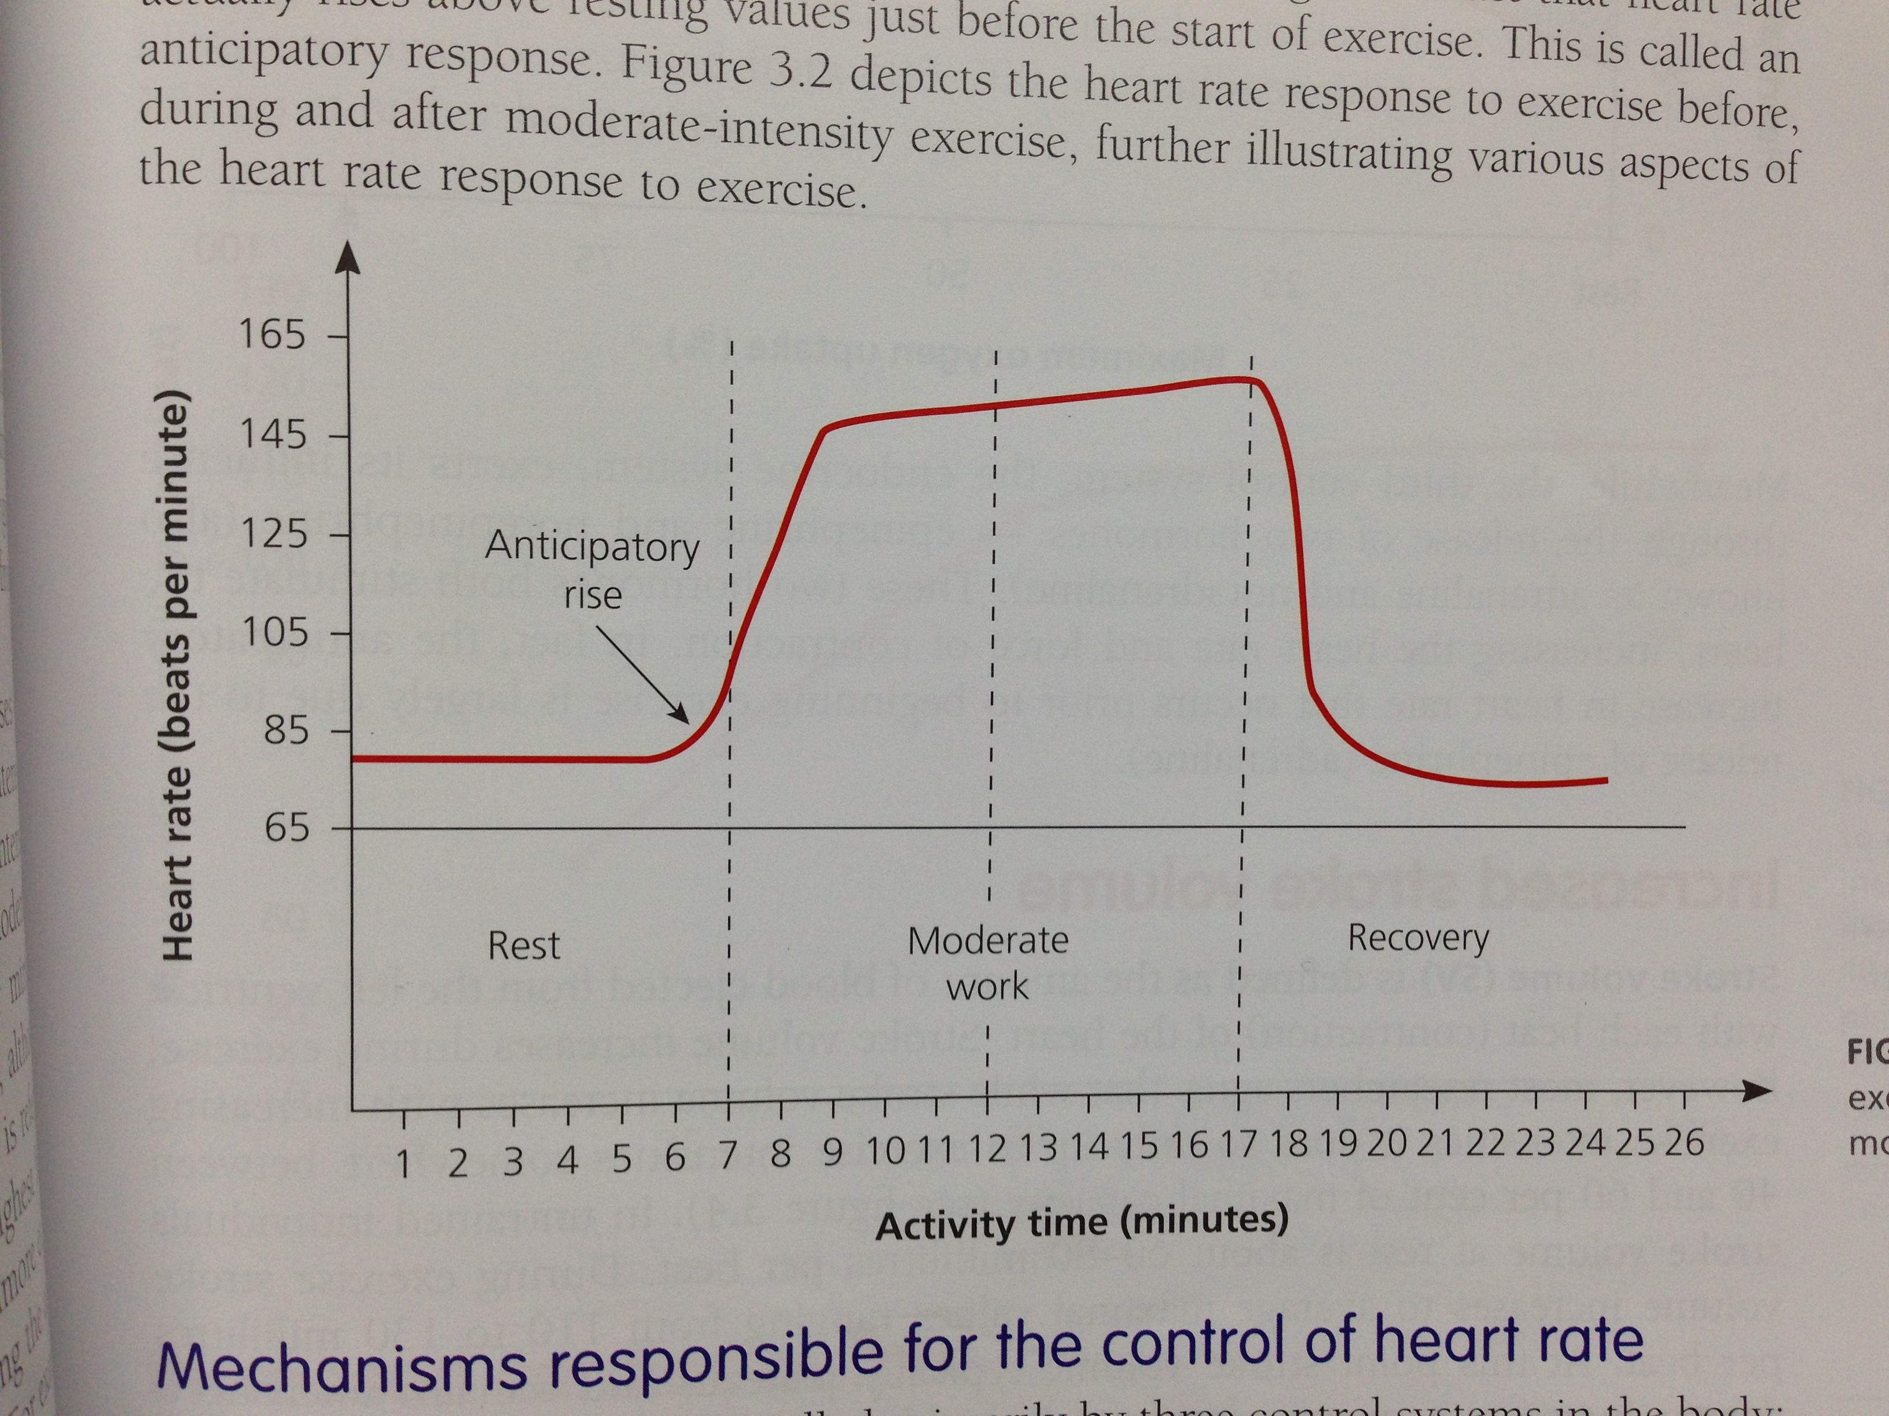
Standard levels in a relatively fit athlete
Response |  | @ rest | @ max intensities
Respiratory | Respiratory Rate (breaths/min) | 12 | 30
Cardiovascular | Heart Rate (beats/min) | 70 | 220 - age
 | Stroke Volume (ml/beat) | 75 | 150
 | Cardiac Output (L/min) | 5.2 | 28.5
Muscular | a-vO₂ difference (ml O₂/100ml blood) | 5 | 15-18

When reading a graph
- Clearly read the axis so that you understand what you are looking at
- If there is additional information available, use this to make further sense of the graph
- If the question is directly related to the graph, always use the figures from it. Don’t make up values.
Things to note when drawing a graph
- Starting point @ rest (see table above)
- Slight anticipation before commencement of Physical Activity
- Sharp rise to meet O₂ demands of the exercise
- @ sub max intensities, achieving a Steady State (O₂ supply meets O₂ demand)
- @ max intensities, a slower increase until the end of the activity
- During recovery, there will be a gradual decline to return to resting levels

