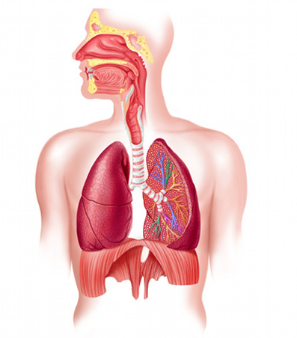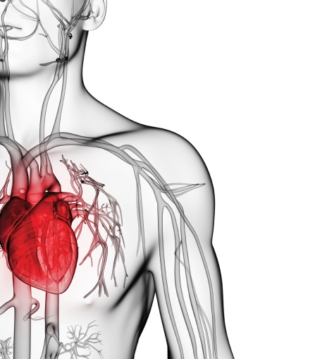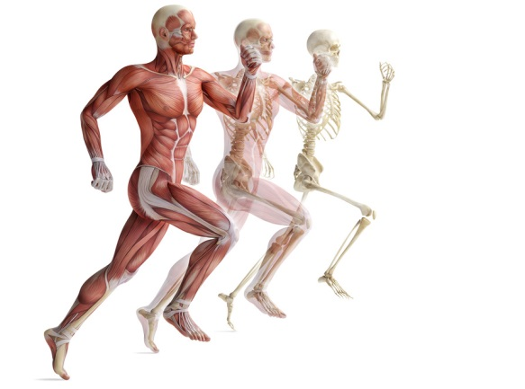

**Muscular System**

**Cardiovascular System**

**Respiratory System**

Complete a 20 min bout of exercise and then record what acute responses you experienced in the 3 body systems (Respiratory, Cardio-vascular & Muscular)

What does ‘acute responses to Physical Activity’ mean?

**Acute Responses to Physical Activity**