****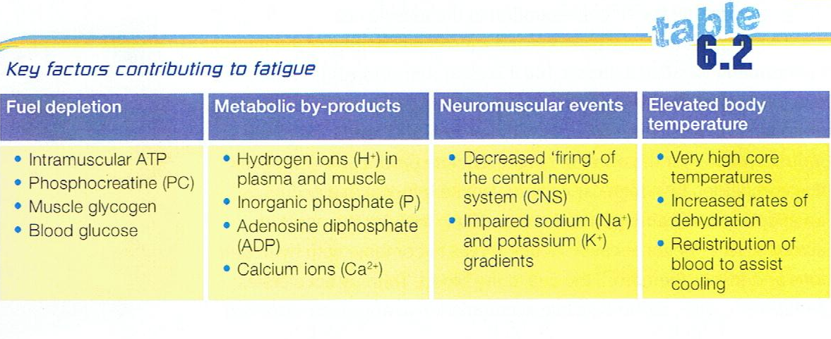

**Fuel Depletion**

* Intramuscular ATP
  + Last for 2 Seconds
  + Restore through Passive recovery
  + Stronger Aerobic ES will result in faster replenishment
* PC
  + Last for 10 seconds
  + Restore through Passive recovery (30sec=70%, 3min=98%)
  + Stronger Aerobic ES will result in faster replenishment
* Glycogen
  + Muscle glycogen utilised first, then liver
  + Considered a fatiguing factor after 60mins of continuous exercise
  + Restored through replenishment during and post exercise bout (best results with high GI in first 30mins after)
  + Will ‘Hit the wall’ 2-3hrs into an endurance event

**Metabolic by-products**

* Hydrogen Ions (H+)
  + Increased amounts of H+ cause muscle acidity which slows the actions of glycolytic enzymes and the rate of glycogen breakdown
  + Occurs when the Anaerobic Glycolysis ES has a higher contribution towards energy production
  + LIP is an identifying factor of H+ accumulation
  + Lactate Inflection Point
    - The L.I.P. has been exceeded when lactate appearance in the blood is greater than lactate removal from the blood. (Lactate rises from a steady state)
    - When the L.I.P. is reached most energy is still supplied aerobically, however, an increased reliance on the Anaerobic Glycolysis energy system due to an increased intensity results in the lactate increase
    - Remember: It is not the lactate itself that causes fatigue. The rise in blood lactate is a good indicator of the amount of H+ that is in the muscle
  + Removed best when oxygen levels are above resting and an increased blood flow is present.
    - Active Recovery
    - Massage
    - Contrast bathing
* Inorganic Phosphate (Pi)
  + slows the release of calcium ions and reduces the contraction force of muscles
  + Occurs when the ATP-PC & Anaerobic Glycolysis ES has a higher contribution towards energy production
  + Removed best during passive recovery where high levels of O2 are available
* ADP
  + accumulates during explosive activities and reduces the power muscles can exert
  + Occurs when the ATP-PC & Anaerobic Glycolysis ES has a higher contribution towards energy production
  + Removed best during passive recovery where high levels of O2 are available

**Neuromuscular Factors**

* Decreased firing of the CNS
  + Brain detects fatigue – weaker signals sent to muscles to reduce intensity (self-protection)
  + As intensity increases, Ach release is slowed resulting in less forceful contractions
  + Passive recovery is the best
* Impaired sodium and Potassium Gradient
  + Impaired sodium–potassium pump function can restrict muscular contractions.
  + Sports and electrolyte drinks can help to maintain and replenish electrolyte levels

**Elevated Body Temperature**

* Causes fatigue via
  + Less oxygen being delivered to the working muscles
    - Due to an increase in blood being sent to the skin for thermoregulation
    - Results in an increase in Q & HR
    - Results in a greater reliance on Anaerobic Glycolysis ES, meaning a build up of Metabolic by-products
* Leads to dehydration which causes
  + Impaired mental function
  + Decreased plasma volume
  + Increased body temperature
  + Further blood flow to the skin