Practice questions with various stimulus materials

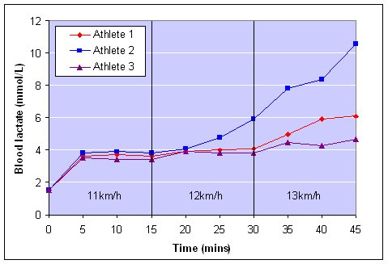
- Identify which athlete is the trained and untrained athlete? Justify your response
________________________________________________________________________________________________________________________________________________________________________________________________________________________________________________________________________________________________________________________________________________________________________________________________________________________________________________________________________________________________________________________________________________________________________________________________________________________________________________________________________________________________________________________________________
- Has athlete 2 reached LIP and how did you come to this conclusion?
____________________________________________________________________________________________________________________________________________________________________________________________________________________________________________________________________________________________________________________________________________________________________
- What would be the most suitable method of recovery for athlete 2?
__________________________________________________________________________________________________________________________________________________________________________________

- What is the predominant energy system during each speed for athlete 1?
____________________________________________________________________________________________________________________________________________________________________________________________________________________________________________________________________________________________________________________________________________________________________

- What is the main cause of fatigue in stage 3?
____________________________________________________________________________________________________________________________________________________________________________________________________________________________________________________________________________________________________________________________________________________________________

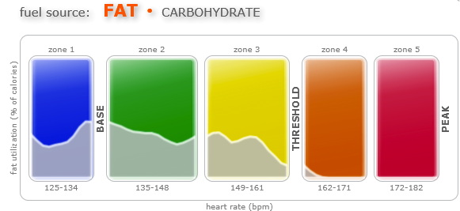
- Identify which energy system utilises fats as an energy source?
__________________________________________________________________________________________________________________________________________________________________________________
- Which energy system is the major contributor in zone 4? Use data from the graph to justify your answer.
_____________________________________________________________________________________________________________________________________________________________________________________________________________________________________________________________________________________________________________________________________________________________________________________________________________________________________________________________
- a) If an athlete worked in the zone 4 and 5 for an extended period of time, what would be the fatiguing mechanisms that would prevent them from maintaining this intensity?
___________________________________________________________________________________________________________________________________________________________________________________________________________________________________________________________________________
b) How do these fatiguing mechanisms decrease performance?
__________________________________________________________________________________________________________________________________________________________________________________________________________________________________________________________________________
- Outline the energy system interplay occurring at the end of a beep test when an athlete is working in zone 5
______________________________________________________________________________________________________________________________________________________________________________________________________________________________________________________________________________________________________________________________________________________________________________________________________________________________________________________________________________________________________________________________________________________
- Explain why you utilise more fats as a fuel source at lower intensities?
____________________________________________________________________________________________________________________________________________________________________________________________________________________________________________________________________________________________________________________________________________________________________
- What fuel source is predominant at higher heart rate zones?
_____________________________________________________________________________________________________________________________________________________________________________________________________________________________________________________________________________________________________________________________________________________________________________________________________________________________________________________________

ANSWERS

- Identify which athlete is the trained and untrained athlete? Justify your response
- Trained athlete is Athlete B as their LIP is delayed (reached at higher intensities)
- Untrained athlete is Athlete 1 as they achieve LIP at lower intensities, indicating that they rely on their Anaerobic Glycolysis energy system earlier.

- Has athlete 2 reached LIP and how did you come to this conclusion?
- Yes at around the 20 min mark of exercise
- LIP is the last point at which Lactate is at a steady state (lactate production=lactate removal)
- After the LIP, lactate will continue to rise rapidly in the blood stream

- What would be the most suitable method of recovery for athlete 2?
- As Athlete 2 has completed an Aerobic ES dominant activity (longer than 90 secs) and also had an increased contribution from the anaerobic glycolysis energy system it would be best to perform an ACTIVE recovery.
- This will aid the removal of Metabolic by-products by maintain a higher O2 levels whilst also having a higher Q.

- What is the predominant energy system during each speed for athlete 1?
- Aerobic ES would be dominant for all three speeds, however there would be an increased contribution from the Anaerobic Glycolysis ES during the 3rd stage (13km/h). This is evident due to the increase in Lactate, which is a by-product of this system.

- What is the main cause of fatigue in stage 3?
- During stage 3, blood lactate levels are increasing which indicates that H+ would also be accumulating in the muscles.
- Increased H+ concentrations will result in an increased acidity in the muscle cells, which intern slows the breakdown of glycogen and release of energy.
- Identify which energy system utilises fats as an energy source?
- The Aerobic energy system as the graph indicates that fats are utilised at lower (sub-maximal) intensities (% of HR).

- Which energy system is the major contributor in zone 4? Use data from the graph to justify your answer.
- Use of fat as an energy source is very small in Zone 4 of the graph, suggesting that the athlete is working at a high intensity as the body requires a large amount of O2 available to break down fats
- It is likely that the Anaerobic Glycolysis energy system would be the major contributor in zone 4.

- a) If an athlete worked in the zone 4 and 5 for an extended period of time, what would be the fatiguing mechanisms that would prevent them from maintaining this intensity?
- In Zone 4 & 5 the athlete would be working at high intensities (Above 85% max HR).
- As you are working for an extended period of time at an intensity above sub-max your Anaerobic Glycolysis energy system would be providing a large percentage of the energy required.
- This would result in an accumulation of H+ in the muscles.

b) How do these fatiguing mechanisms decrease performance?
- Increased H+ concentrations will result in an increased acidity in the muscle cells, which intern slows the breakdown of glycogen and release of energy.

- Outline the energy system interplay occurring at the end of a beep test when an athlete is working in zone 5
- At the conclusion of the beep test, an athlete would be working at a maximum intensity and would therefore have a greater reliance on their anaerobic energy system.
- However, as they would have been moving for more than 90seconds before this stage, the aerobic energy system would still be dominant and be providing most energy requirements
- PC would have depleted throughout the test and so the ATP-PC energy system would provide no energy to this final stage in the beep test.

- Explain why you utilise more fats as a fuel source at lower intensities?
- Fats require far more O2 to break down and release energy than compared to glycogen
- Therefore fats are utilised more at submaximal intensities as your body has excess O2 which can be used to break them down
- Additional note: The fitter or stronger aerobic energy system the athlete has, the greater their ability to utilise more fats at higher intensities due to their increased ability to deliver more O2 to the working muscles. This means that they will use less glycogen throughout the event and be able to use these saving with higher intensity efforts later in the activity. This is known as ‘Glycogen Sparing’.

- What fuel source is predominant at higher heart rate zones?
- They are working at higher intensities in the higher HR zones so the Anaerobic Energy Systems would be called upon.
- The ATP-PC energy system breaks down PC to resynthesise ATP
- The Anaerobic Glycolysis energy system breaks down glycogen to resynthesise ATP

